Student Performance Descriptive Analysis

Introduction
This report provides an in-depth analysis of student performance, based on data from Sling Academy, to uncover insights for better student development and strategic decision-making, using Exploratory Data Analysis and Data visualization in Excel.

Objective
The objective of this project is;
- To identify the key features that influence student performance
- To develop an interactive dashboard to monitor the real - time student performance

Dataset Description
The selected dataset for this project was “Student-Scores”, sourced from Sling Academy. This dataset includes 2000 data and 17 attributes, including;

Attribute Name | Attribute Description | Data Type
ID | Unique Student Identifier | Integer
First_name | Student’s first name | String
Last_name | Student’s last name | String
Email | Student’s academy email | String
Gender | The gender of a student. | String
Math_score | Mathematics score | Float
History_score | History score (0 – 100) | Float
Physic_score | Physic score (0 – 100) | Float
Chemistry_score | Chemistry score (0 – 100) | Float
Biology_score | Biology score (0 – 100) | Float
English_score | English score (0 – 100) | Float
Geography_score | Geography score (0 – 100) | Float
Part_time_job | Do students have a part-time job or not | Boolean
Absence_days | Total number of days the students do not attend the class | Integer
Extracurricular_activities | Students join any extracurricular activities | Boolean
Weekly_self_study_hours | Total number of hours the student studies (Per Week) | Integer
Career_aspiration | Student’s career aspirations or goals for the future | String

Source:https://www.slingacademy.com/article/student-scores-sample-data-csv-json-xlsx-xml/#student-scores.xlsx

Data Preparation
Before analysing data, data preparation is required to ensure it is valid and easier to analyse. Data preparation also allows the analyser to identify additional hidden outcomes, thereby improving data accuracy. Data preparation for this project includes checking and removing duplicate and missing values, and feature engineering.

- Identify and Remove Missing Value
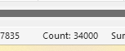
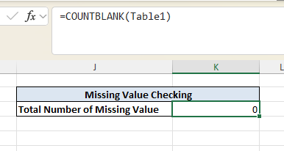

The image above shows that the total number of values in this dataset was 34000 (2000 data points × 17 columns). It can prove that there are no missing values in this dataset. Additionally, the formula “COUNTBLANK” can count the total number of missing values. The formula also proves that the number of missing values in this dataset was 0.

- Identify and Remove Duplicate Value
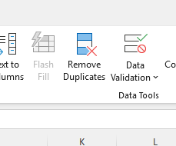
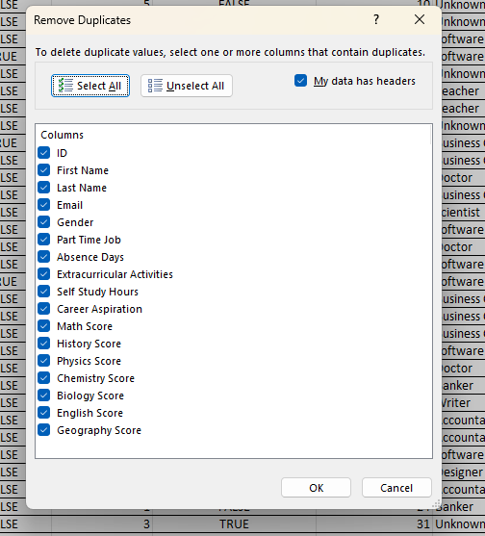
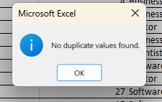
The Remove Duplicates function was applied to remove duplicate records, and the result above shows that this dataset contains no duplicates.

- Feature Engineering
In this phase, new features will be created to provide more meaningful and logical insight. The new features to be created in this dataset are;

- Full Name
Formula: (=TEXTJOIN(" ",TRUE,Table1[@[First Name]:[Last Name]])
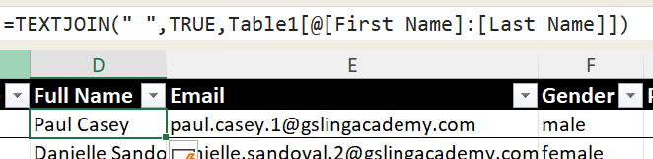

- Grade for each subject score (Math Grade, History Grade, Physics Grade, Chemistry Grade, Biology Grade, English Grade, and Geography Grade)
Formula: (=IFS([@[Math Score]]>=90,"A+",[@[Math Score]]>=80,"A", [@[Math Score]]>=75,"A-",[@[Math Score]]>=70,"B+",[@[Math Score]]>=65,"B",[@[Math Score]]>=60,"B-",[@[Math Score]]>=50,"C",[@[Math Score]]>=40,"D",[@[Math Score]]<40,"F"))
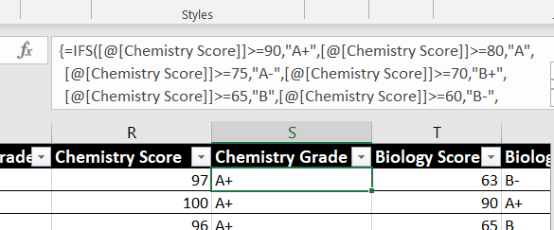

- Total Score
Formula: SUM([@[Math Score]],[@[History Score]],[@[Physics Score]],[@[Chemistry Score]],[@[Biology Score]],[@[English Score]],[@[Geography Score]])
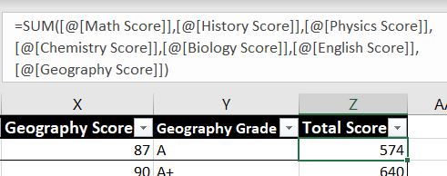

- Average Score
Formula: =AVERAGE([@[Math Score]],[@[History Score]],[@[Physics Score]],[@[Chemistry Score]],[@[Biology Score]],[@[English Score]],[@[Geography Score]])
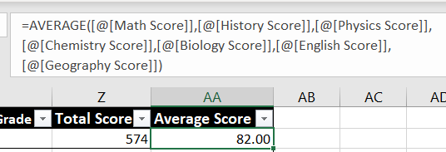

- Overall Grade
Formula: =IFS([@[Average Score]]>=90,"A+",[@[Average Score]]>=80,"A", [@[Average Score]]>=75,"A-",[@[Average Score]]>=70,"B+",[@[Average Score]]>=65,"B",[@[Average Score]]>=60,"B-",[@[Average Score]]>=50,"C",[@[Average Score]]>=40,"D",[@[Average Score]]<40,"F")
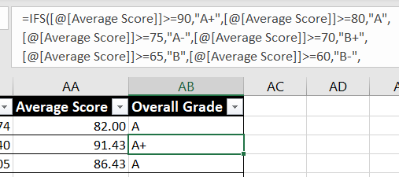

- Ranking in the Academy
Formula: RANK(AA2,$AA$2:$AA$2001,0)
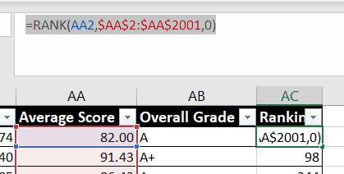

- Attendance Performance
Formula: IFS([@[Absence Days]]<3,"Excellent",[@[Absence Days]]<=6,"Good",[@[Absence Days]]>6,"Poor")
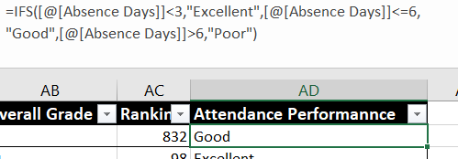

Data Finding and Analysis
After the data preparation phase, the data is considered clean and ready for analysis. In this phase, a Pivot table and a chart will be applied to generate insights from the data.

- Gender Distribution
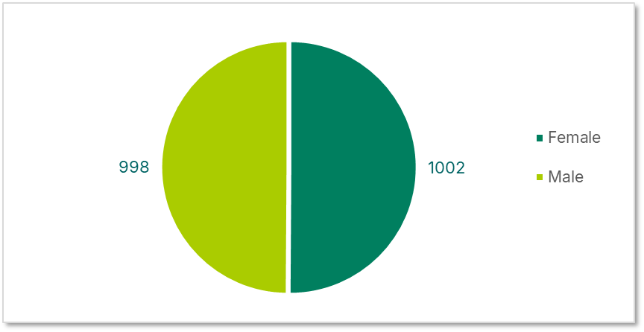
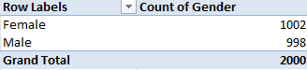
Based on the pie chart and pivot table above, 1002 students at Sling Academy were female,, while 998 were male.

- Career Aspiration
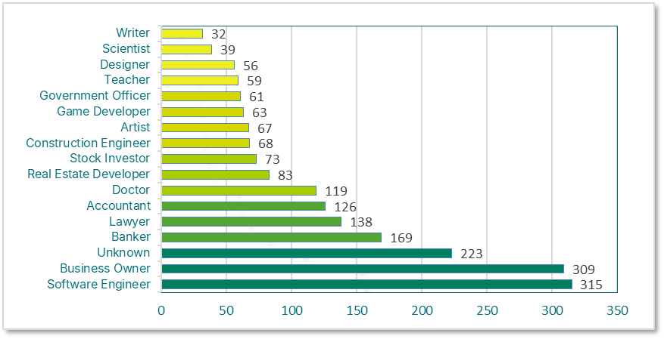
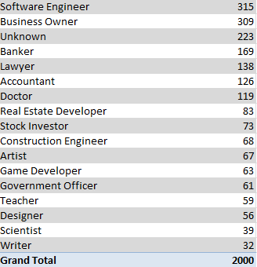
According to the pivot table and horizontal bar chart, 315 students dream of becoming software engineers, followed by business owners (309), and 223 students have not yet defined their career aspirations. Sling Academy suggested organising a counselling program to provide career guidance and suggestions based on the students' performance.

- Subject Performance
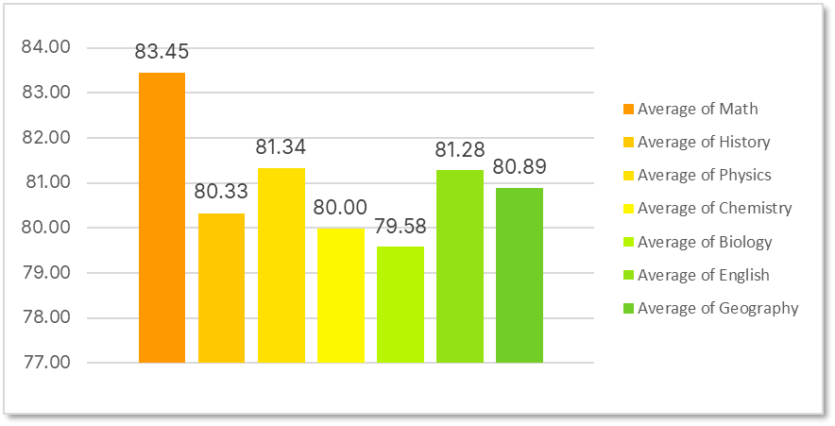
In terms of subject performance, Mathematics recorded the highest average score with 83.45. Then, it’s followed by Physics (81.34) and English (81.28). Biology had the lowest average score, ats 79.58. It’s reflected that Biology has potential challenges in content understanding and engagement.

- Overall Grade Distribution
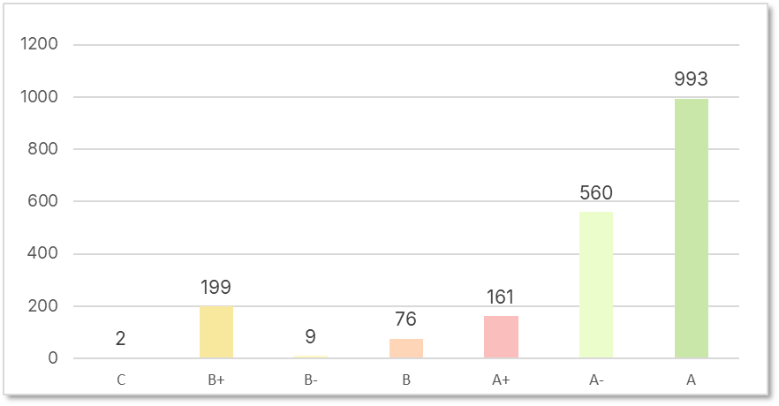
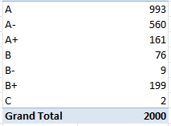
The majority of the students in Sling Academy score A (993 students) and A- (560 students) for the overall result. The lower grades, like B- and C, are minimal, with 9 and 2 students, respectively. It shows that the student's performance is more satisfactory. However, there is still room for improvement.
- Top 10 Students Performance
Name |  | Average Score | Ranking
Lisa Mitchell |  | 96.14 | 1
Todd Howard |  | 95.86 | 2
Paula Hernandez |  | 95.86 | 2
Mary Arnold |  | 95.71 | 4
Paul Shaffer |  | 95.71 | 4
Daniel Lewis |  | 95.29 | 6
Nicholas Clayton |  | 95.29 | 6
Lance Nelson |  | 95.14 | 8
Scott Weaver |  | 95.00 | 9
Kelly Morris |  | 95.00 | 9

The academic competition at this institution is very strong, as seen by the top-performing students' scores of 95.00 to 96.14. The top students' continuously exceptional performance and the close gap in achievement at the highest level are demonstrated by the small score differences among them.
- Part-Time Job Distribution
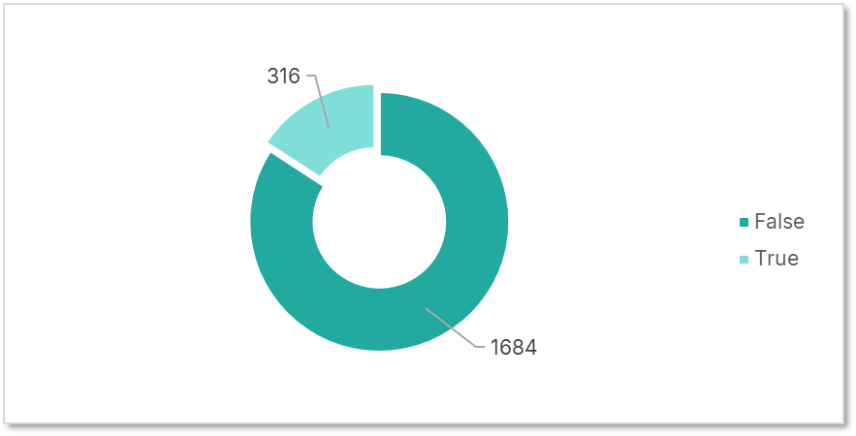
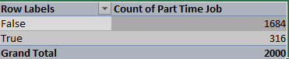
There are 1684 students, or 84.20% of the students do not take any part-time job, whereas 316 students or 15.8% of 2000 students, have part-time jobs. This result shows that most students indicate a strong focus on academic activities.

- Attendance Performance
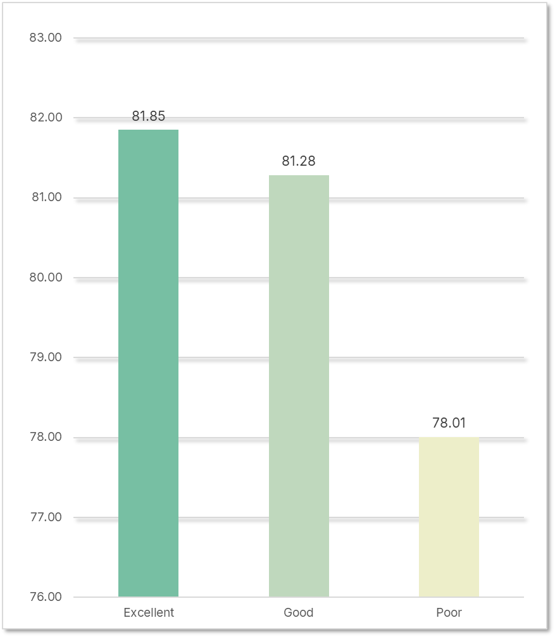
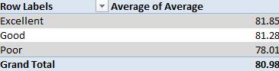
The highest average score of 81.85 was reached by students with Excellent attendance, closely followed by those with Good attendance (81.28). Students with poor attendance, on the other hand, had a much lower average score of 78.01.
- Extracurricular Activities Distribution
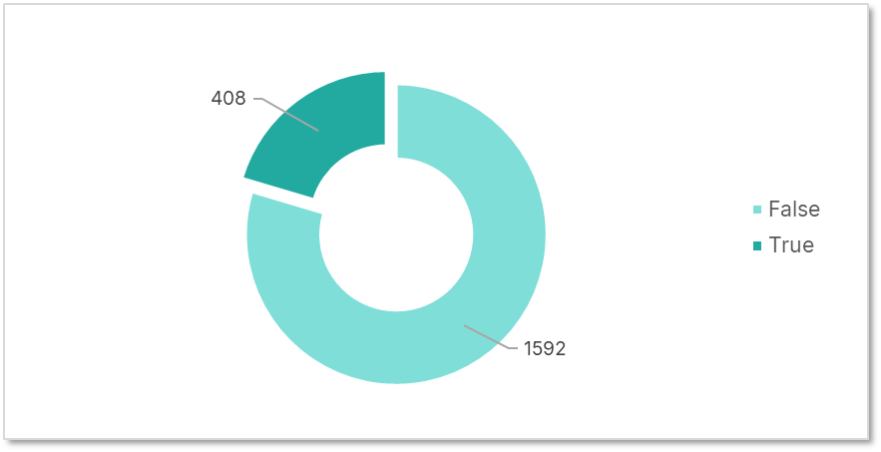
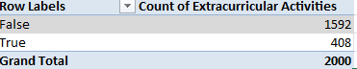
There are 1684 students, or 84.20% of the students do not take any part-time job, whereas 316 students or 15.8% of 2000 students, have part-time jobs. This result shows that most students indicate a strong focus on academic activities.

Data Visualization
Finally, the results will be visualised in the dashboard in Excel, where users can view the pattern and other details. This report is divided into three parts: Profile Distributions, Academic Performance, and Behaviour Analysis. 3 cards offer a quick overview of the overall interaction with student performance. Users can explore the data based on 5 criteria: gender, career aspirations, part-time job, extracurricular activities, and attendance performance. The first part (Profile Distribution) displayed the overall distribution of students' genders at Sling Academy and their career aspirations. Then, the second part, Academic Performance, illustrates the Top 10 students and the overall average grade and subject distribution to identify which students or subjects are strong or weak. The third part of this dashboard is Behaviour Analysis, which identifies the factors that affect students’ performance.
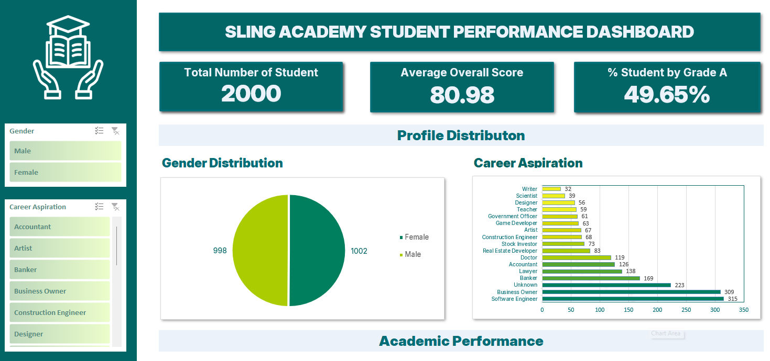

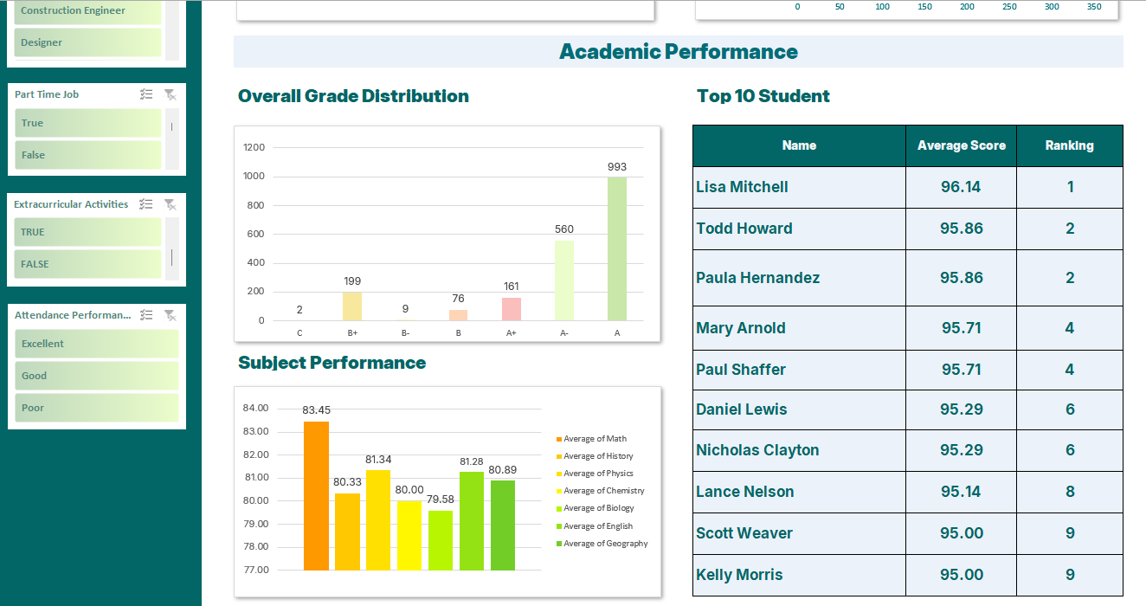
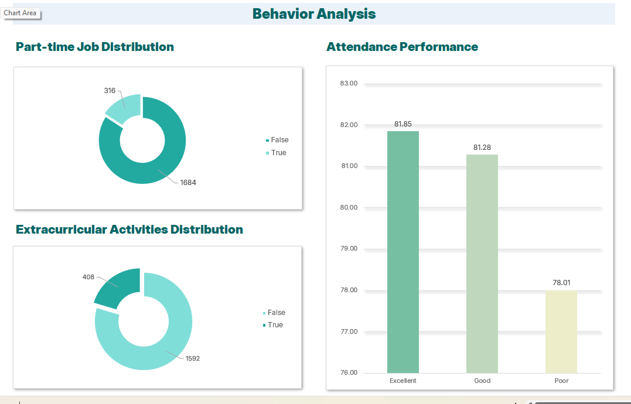

Recommendations
- Tutorial programs - The institution is encouraged to conduct targeted tutorial or review classes for low-performing students and those with poor attendance. These programs help students catch up on missed lessons, strengthen their understanding of key concepts, and improve overall academic performance.
- Counselling & Support Services - Teachers or administrators need to engage with students who consistently miss class to identify the reasons behind the absences and provide mental support, whether academic or personal. It can help address these issues and improve both attendance and performance.
- Increase engagement in extracurricular activities: The university should create and promote a broader range of activities to encourage greater student participation. This will provide students with the opportunity to explore varied interests, develop soft skills such as teamwork and leadership, and cultivate beneficial habits that contribute to both personal growth and academic performance.

